Dear parents, carers, doctors,

re: prescription medications at SKIF Jewish youth camps

Chavershaft! (customary SKIF greeting)

SKIF is a Jewish youth group that has been running camps for children and adolescents in Melbourne since 1951. SKIF and our helfer (youth leaders) are committed to making our camps are accessible and safe for all those who would like to attend. Over recent years, the SKIF helfer have noted increasing numbers of our lageristn (campers) who are taking regular prescribed medications. The task of safely storing and administering these medications for lageristn has become an increasing challenge for the helfer who carry broad pastoral care responsibilities on camp as well as coordinating a busy and exciting program of activities. We are confident that we can work together to make this aspect of camp safer and simpler. In asking for your assistance, I am writing in my capacity as a paediatrician but also as someone who was a skifist (SKIF youth member), lagerist (camper), helfer, and who continues in a supervisory role for SKIF as part of the parent Jewish Labour Bund organisation.

As far as possible, we hope that regular medications can be administered on camp according to the following principles. We are of course happy to discuss exceptions, but we encourage parents or carers to discuss these matters first with your child’s doctor. In my experience, many aspects related to timing and administration of medicine are not so hard and fast as is suggested by the label applied at the pharmacy. For your reference, at the end of this letter there is also a short representative example of a typical day on camp, which may be useful in considering medication timing.

- Medical forms listing regular prescribed medications should be completed and returned at least one week prior to camp. It is not safe for the helfer to find out for the first time on the morning camp leaves that lageristn (campers) are on regular medications. The helfer have been instructed to seek advice from myself or other supervising doctor in the event that this does occur.
- Please contact the helfer prior to camp if regular medications need to be given more than 2 times a day.
- Except where this is clearly not appropriate, the helfer will provide regular medications to lageristn during or immediately after frishtik (breakfast) and/or during or immediately after oventbroyt (dinner). Please confirm with your child’s doctor whether or not instructions listed on pharmacy labels regarding timing of medications in regard to food must be followed.
- Where parents or carers indicate that self-administration by lageristn of medication is acceptable, the helfer will check this with me or other supervising doctor. If self-administration will not be possible, we will contact parents or carers to discuss the most suitable way to manage your child’s medication/s.
- It is important that helfer are only tasked with administering medication prescribed for an individual child. Please ensure your child’s doctor signs their medical form and/or that you provide medications in a container including the pharmacy label or a copy of a recent prescription for that medicine (including the child’s name). The helfer will not administer medication to a lagerist that has been prescribed to another family member.
- Please provide medications in a ziplock bag for 1 medication (in the original box and blister packaging) or in a clear plastic container for more than 1 medication. Please label clearly, with a blank white sticker applied to the container or bag, with first and last name written on the label in large capital letters, not directly on to the bag or container.
- Medication to be administered by helfer will be collected at the bus prior to leaving for camp then securely stored and administered throughout camp.

Parents and carers, please discuss any questions with your child’s doctor first. If you’d like to clarify something about this letter, ask the helfer first. Doctors, please contact me with any questions you may have regarding any aspect of this letter.

Thank you sincerely,

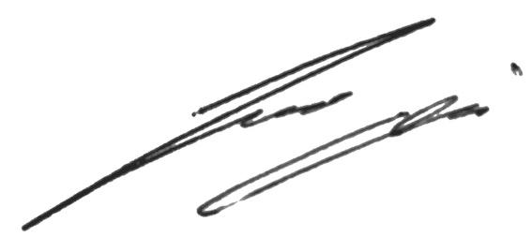

Dr Josh Osowicki
joshuaosowicki@hotmail.com

Example of a typical daily SKIF camp togplan (timetable)
- Oyfshtayn (wake up) – 8 am
- Gymnastic (exercise) – 8:15 am
- Frishtik (breakfast) – 9 am
- Activity* – 10:45 am
- Mitog (lunch) – 1 pm
- Activity* – 2:45 pm
- Swimming (zumer lager/summer camp) or other free play time
- Oventbroyt (dinner) – 6 pm
- Activity* – 8 pm
- Bedtime – 10 to 11 pm (depending on age group)

*lager (camp) activities typically include active outdoor play & more sedentary indoor time

